# **Electronic Health Records with AI Data Visualization:**

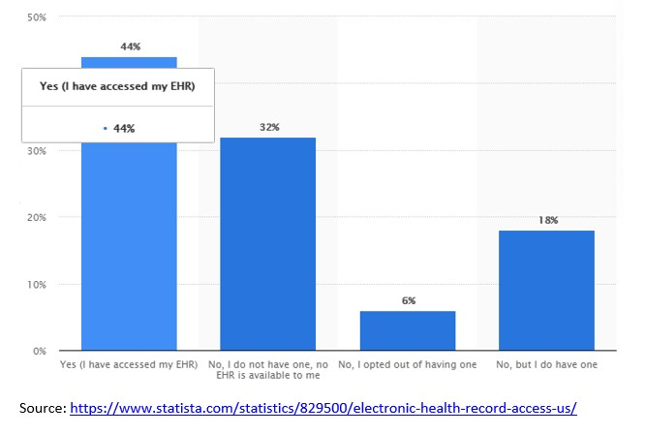

**Topic: How AI and Electronics Health Records can enhance better healthcare**

**Source:** <https://www.statista.com/statistics/829500/electronics-health-recor-access-us/>

**Original Source:** <https://www.accenture.com/t20180306T103559Z__w__/us-en/_acnmedia/PDF-71/accenture-health-2018-consumer-survey-digital-health.pdf>

The above graph states the percentage of people exposed to the usage of Electronic health records. The entire U.S population is taken into consideration. Here we can see, a maximum of 44% of people population have good access to EHR as opposed to 32% of the people without any access to EHR facility. Further, the graph also states the difference between the availability of facility vs the people’s willingness to utilizing the facility for other possible reasons. The drawback here is the other hidden pattern or parameters are unknow which are differing this analysis such as why people are not opting the EHR, are there any trust issue, or recent incidents which have affected the analysis, what duration has been taken into consideration. This is where the AI and machine learning can act as a game-changer for the industry.